

Faculty of Computers and Artificial Intelligence,

Cairo University

**Prepared By:**

Mirette Amin Danial 20190570

Nader Atef 20190575

**Under The Supervision Of:**

Dr. Eman Ahmed

**Algerian Forest Fires**

The dataset is based on the [Canadian Forest Fire Weather Index (FWI) System](https://cwfis.cfs.nrcan.gc.ca/background/summary/fwi?wbdisable=true#:~:text=The%20Fine%20Fuel%20Moisture%20Code,the%20flammability%20of%20fine%20fuel.)

**Dataset features:**

* Date: (DD/MM/YYYY) Day, month ('June' to 'September'), year (2012)

**Weather data observations**

* Temp: temperature noon (temperature max) in Celsius degrees: 22 to 42
* RH: Relative Humidity in %: 21 to 90
* Ws: Wind speed in km/h: 6 to 29
* Rain: total day in mm: 0 to 16.8  
  **FWI Components (Fire Weather Index)**
* Fine Fuel Moisture Code (FFMC) index from the FWI system: 28.6 to 92.5

The Fine Fuel Moisture Code (FFMC) is a numeric rating of the moisture content of litter and other cured fine fuels. This code is an indicator of the relative ease of ignition and the flammability of fine fuel.

* Duff Moisture Code (DMC) index from the FWI system: 1.1 to 65.9

The Duff Moisture Code (DMC) is a numeric rating of the average moisture content of loosely compacted organic layers of moderate depth. This code gives an indication of fuel consumption in moderate duff layers and medium-size woody material.

* Drought Code (DC) index from the FWI system: 7 to 220.4

The Drought Code (DC) is a numeric rating of the average moisture content of deep, compact organic layers. This code is a useful indicator of seasonal drought effects on forest fuels and the amount of smoldering in deep duff layers and large logs.

* Initial Spread Index (ISI) index from the FWI system: 0 to 18.5

The Initial Spread Index (ISI) is a numeric rating of the expected rate of fire spread. It is based on wind speed and FFMC. Like the rest of the FWI system components, ISI does not take fuel type into account. Actual spread rates vary between fuel types at the same ISI.

* Buildup Index (BUI) index from the FWI system: 1.1 to 68

The Buildup Index (BUI) is a numeric rating of the total amount of fuel available for combustion. It is based on the DMC and the DC. The BUI is generally less than twice the DMC value, and moisture in the DMC layer is expected to help prevent burning in material deeper down in the available fuel.

* Fire Weather Index (FWI) Index: 0 to 31.1

The Fire Weather Index (FWI) is a numeric rating of fire intensity. It is based on the ISI and the BUI, and is used as a general index of fire danger throughout the forested areas.

* Classes: two classes, namely “Fire” and “Not Fire”

Target class distribution

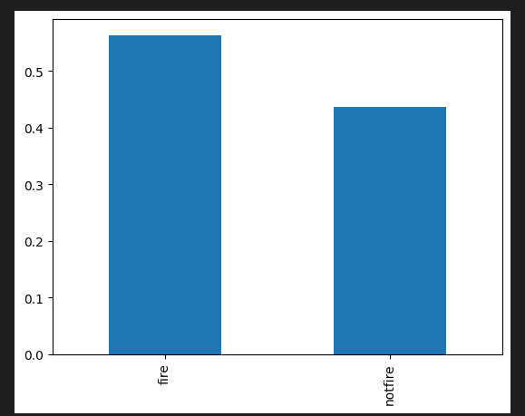

This is a scatter plot that uses the soft predictions to scale the color of the point between each cluster

We used PCA first to visualize the data in a 2D graph

